

IIIT SONEPAT

AP LAB FILE

NAME- RACHIT SONTHALIA

ROLL NO.- 11911079

BRANCH- CSE

|  |  |
| --- | --- |
| **PROGRAM 1**  <!DOCTYPE html> | |
| <html lang="en" dir="ltr"> |
| <head> |
| <meta charset="utf-8"> |
| <title>Register</title> |
| </head> |
| <body> |
| <center><h1>REGISTRATION FORM</h1></center> |
| <h5><time></time></h5> |
| <feildset> |
| <form action="meta.html" method="post" autocomplete="on"> |
| <!--hidden input type contains hidden information that will also be processed in action browser--> |
| <input type="hidden" name="recipient" value=""> |
| <input type="hidden" name="subject" value=""> |
| <input type="hidden" name="redirect" value=""> |
| <!--input type text inserts a text feild to be input by user--> |
|  |
| <p><feildset><label>First Name: |
| <input type="text" placeholder="First Name" id="firstname"name="name" size="25" maxlength="30"> |
| </label>(First name)</feildset></p> |
|  |
| <p><label>Last Name: |
| <input type="text" placeholder="Last Name" id="lastname"name="name" size="25" maxlength="30"> |
| </label>(Last name)</p> |
| <p> |
| <label>Date: |
| <input type="date"/> |
| (yyyy-mm-dd) |
| </label> |
| </p> |
| <p><label>E-mail address: |
| <input type="email" name="details" placeholder="name@domain.com" required></label> |
| </p> |
| <p><label>Phone Number |
| <input type="tel" name="details" placeholder="##########" pattern="\d{10}" required></label> |
| </p> |
| <p> |
| <label>Datetime Local: |
| <input type="datetime-local"/> |
| (yyyy-mm-ddThh:mm, such as 2012-01-27T03:15) |
| </label> |
| </p> |
| <p> |
| <label for="txtList">Qualifications: |
| <input type="text" id="txtList" placeholder="Qualifications" list="Qualifications"> |
| <datalist id="Qualifications"> |
| <option value="Matric"> |
| <option value="High School"> |
| <option value="UG"> |
| <option value="PG"> |
| </datalist> |
| </label> |
| </p> |
| <p> |
| <strong>Team you liked</strong><br> |
| <label>Programming team |
| <input type="checkbox" name="teamselection" value="programming"> |
| </label> |
| <label>Creative team |
| <input type="checkbox" name="teamselection" value="creative"> |
| </label> |
| <label>Mulltimedia team |
| <input type="checkbox" name="teamselection" value="multimedia"> |
| </label> |
| <label>Testing team |
| <input type="checkbox" name="teamselection" value="testing"> |
| </label> |
| </p> |
| <p> |
| <strong>Confirm</strong> |
| <label>Yes |
| <input type="radio" name="confirmation" value="yes" checked> |
| </label> |
| <label>No |
| <input type="radio" name="confirmation" value="no"> |
| <!--name class must be same in a given paragraph--> |
| </label> |
| </p> |
| <p> |
| <label>Rate our site |
| <select name="rating"> |
| <option selected>Amazing</option> |
| <option>10</option> |
| <option>9</option> |
| <option>8</option> |
| <option>7</option> |
| <option>6</option> |
| <option>5</option> |
| <option>4</option> |
| <option>3</option> |
| <option>2</option> |
| <option>1</option> |
| <option>Awful</option> |
| </select> |
| </label> |
| </p> |
| <p> |
| <label> |
| Comments<br> |
| <textarea name="comments" rows="4" cols="40">Enter your comment</textarea> |
| </label> |
| </p> |
| <p> |
| <input type="submit" value="Submit"> |
| <input type="reset" value="Clear"> |
| </p> |
| </form> |
| </feildset> |
| </body> |
| </html>  **OUTPUT:** |

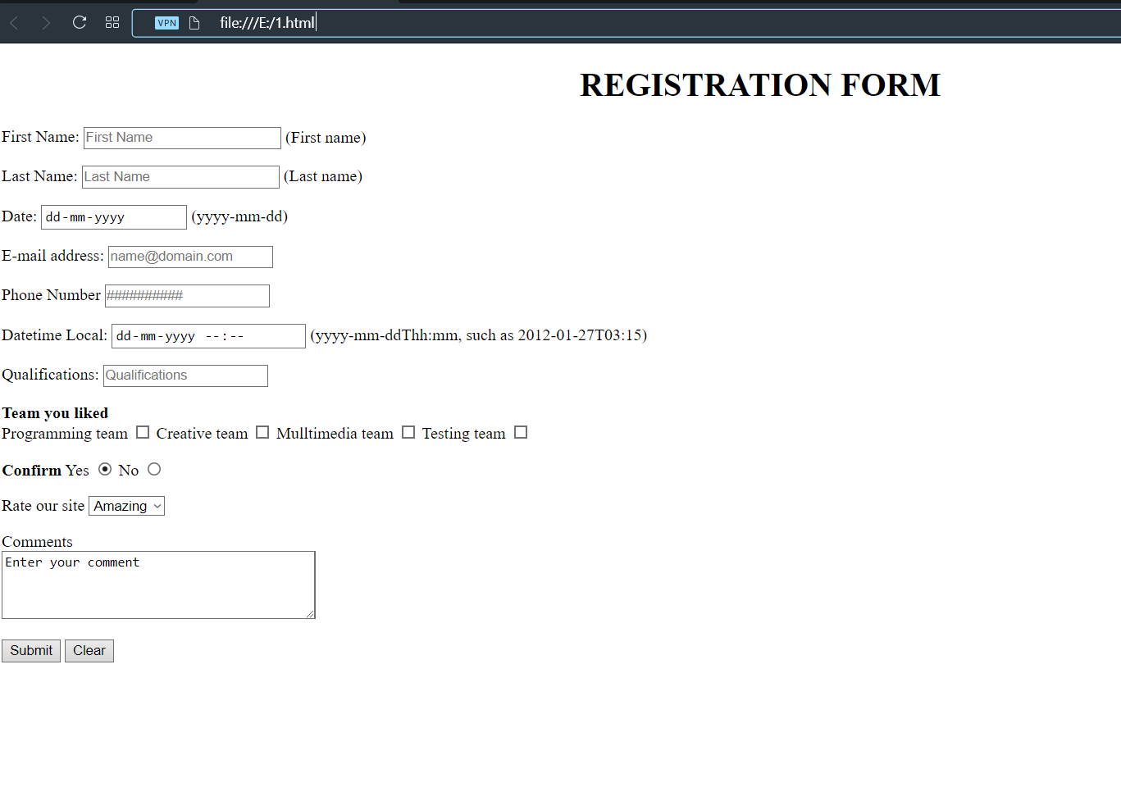

**PROGRAM-2**

<html>

<head>

<title>Hello World!!</title>

<style type ="text/css">

#h1 {

text-decoration-color: rgb(57, 99, 238);

}

#h2 {

text-emphasis-color: rgb(84, 119, 226);

position: relative;

left: 2000px;

}

body {

margin: 0px 0px 0px 0px;

background-color: black;

color: aliceblue ;

}

#frame {

padding-top: 50px;

padding-right: 10px;

}

#earth {

border-radius: 300px;

float: center;

padding-left: 10px;

}

#whole {

background-color: gray;

border-radius: 12px;

margin: 0px 100px 0px 100px;

padding-left: 10px;

padding-bottom: 10px;

padding-right: 10px;

padding-top: 50px;

}

#about-earth {

text-align: center;

text-size-adjust:150%;

}

#ribon {

position: fixed;

background-color: lightslategray;

border-radius: 20px;

margin-left: auto;

margin-right: auto;

width: 100%;

text-align: center;

font-size: large;

}

#button {

border-radius: 10px;

font-family: 'Franklin Gothic Medium', 'Arial Narrow', Arial, sans-serif;

font-weight: 200;

background-color: dodgerblue;

height: 7%;

width: 7%;

}

#button:hover {

background-color: darkblue;

color: antiquewhite;

}

#moon {

text-decoration: none;

}

#moon:hover {

color:darkblue;

text-decoration: underline;

text-transform: uppercase ;

}

</style>

</head>

<body>

<div id="ribon"><p>Welcome to the 1<sup>st</sup> website . Please suggest changes &#123Only Those that I can change&#125</p></div>

<div id="whole"><p id="h1"><h1 align="center">Hello World!!</h1></p>

<p id="h2"><h2 align="center">A few facts about world we live in</h2></p>

<iframe id="frame" width="560" height="315" src="https://www.youtube.com/embed/FG0fTKAqZ5g" frameborder="0" allow="accelerometer; autoplay; encrypted-media; gyroscope; picture-in-picture" allowfullscreen align="right"></iframe>

<p><img id="earth" src="https://cdn.britannica.com/25/160325-050-EB1C8FB7/image-instruments-Earth-satellite-NASA-Suomi-National-2012.jpg" height="360" width="360"></p>

<p id="about-earth">Earth is a third planet from the Sun and is the largestof terrestial planets. Unlike the other planets in solar system that are named after classic deities the Earth's name comes from the<br>

Anglo-Saxon word <strong>erda</strong> which means ground or soil. The earth was formed approximately 4.54 billion years ago and is only known planet to support life.

<hr>

<h2>About earth</h2>

<ul>

<li><b>Mass</b>:5.972&#215;10<sup>24</sup>kg

<li><b>Diameter at equater</b>:12,756km</li>

<li><b>Satellites</b>:<a id="moon" href="https://en.wikipedia.org/wiki/Moon">The moon</a>

</ul>

<hr>

<p><h2>Top 3 earth facts</h2></p>

<ol>

<li>The earth rotation is gradually slowing.</li>

<li>A yeaar isn't exactly 365 days,and the earth doesn't take 24 hours to rotate.</li>

<li>70&#37; of Earth's surface is water, and only one third of its fresh water is unfrozn.</li>

</ol>

</ul>

<hr>

<table>

<tbody>

<thead>

<tr>

<td>Name</td>

<td>Radius</td>

<td>Average<br>Temperature</td>

</tr>

</thead>

<tr>

<td>Mars</td>

<td>3,390km</td>

<td>-55&#8451</td>

</tr>

<tr>

<td>Venus</td>

<td>6,052km</td>

<td>460&#8451</td>

</tr>

</tbody>

</table>

<hr>

<p><h3>Want to know more</h3></p>

<p><form action="https://www.livescience.com/19102-amazing-facts-earth.html">

<input id="button" type="submit" value="Click here" target="_blank">

</form></p></div>

</body>

</html>

OUTPUT:

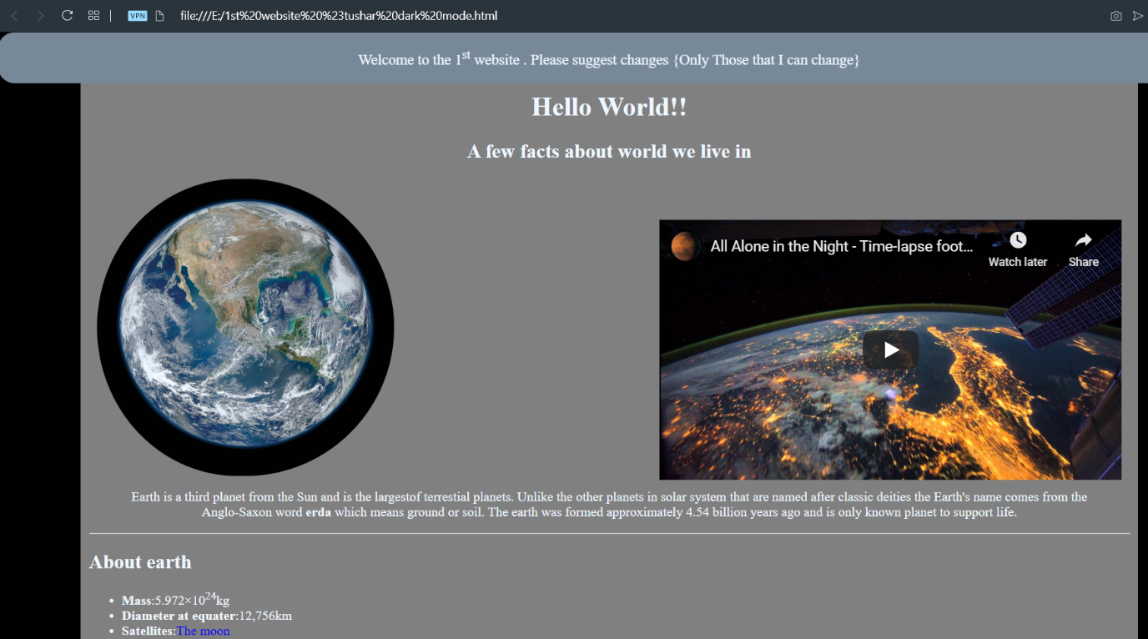

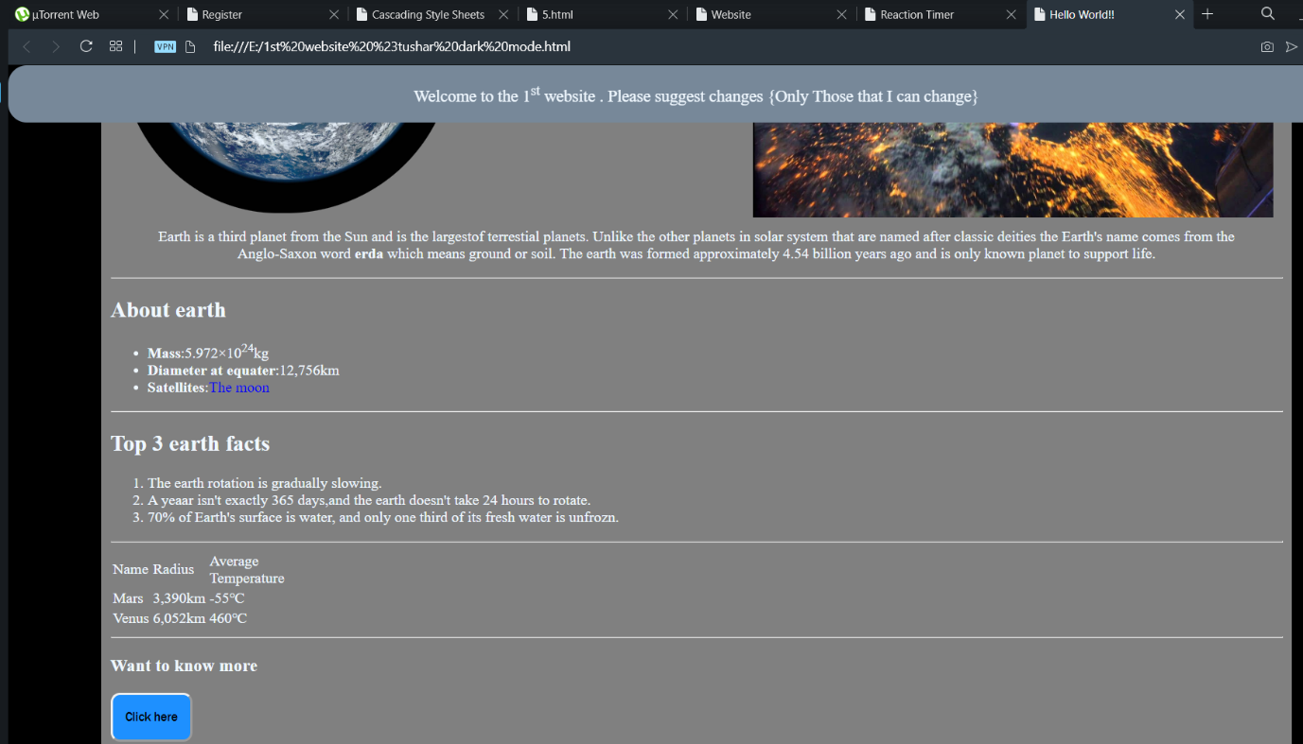

**PROGRAM-3**

|  |
| --- |
| <!DOCTYPE html> |
|  | <html lang="en" dir="ltr"> |
|  | <head> |
|  | <meta charset="utf-8"> |
|  | <title>Cascading Style Sheets</title> |
|  | <style media="screen" type="text/css"> |
|  | body |
|  | { |
|  | background-color: rgb(0,0,122,0.3); |
|  | //background-image: url(img1.png); |
|  | // background-repeat: no-repeat; |
|  | // background-size: contain; |
|  | } |
|  | p |
|  | { |
|  | padding-top:10pt; |
|  | paddind-bottom:10pt; |
|  | text-indent: 1em; |
|  | } |
|  | em |
|  | { |
|  | font-weight : normal; |
|  | color : #6F0F0F; |
|  | } |
|  | h1 |
|  | { |
|  | font-family : tahoma,san-serif,helvetica; |
|  | border-bottom:2px dotted blue; |
|  | } |
|  | p |
|  | { |
|  | font-size : 12pt; |
|  | font-family : san-serif,arial; |
|  | } |
|  | .special |
|  | { |
|  | color : purple; |
|  | } |
|  | a |
|  | { |
|  | text-decoration:none; |
|  | } |
|  | a:hover |
|  | { |
|  | text-decoration: underline; |
|  | font-weight:bold; |
|  | color:green; |
|  | } |
|  | a:visited |
|  | { |
|  | color:hotpink; |
|  | } |
|  | a:active |
|  | { |
|  | background-color:rgba(126, 0, 0, 0.4); |
|  | } |
|  | li |
|  | { |
|  | margin-left: 40px; |
|  | } |
|  | aside |
|  | { |
|  | font-size: .8em; |
|  | float:right; |
|  | } |
|  | table |
|  | { |
|  | border-collapse: collapse; |
|  | border-style:outset; |
|  | } |
|  | </style> |
|  | </head> |
|  | <body> |
|  | <h1 class="special"><center>Cascading Style Sheets(CSS3)</center></h1> |
|  | <a href="#W3C">Go to W3C</a> |
|  | <h3>WHAT IS CSS3?</h3> |
|  | <p>Formatting and presentation of any HTML document is done by using cascading style sheets(CSS3).</p> |
|  | <p style="font-size: 18pt;">The th\ree way of using CSS3 are : </p> |
|  | <ul> |
|  | <li>INLINE STYLING</li> |
|  | <li>EMBEDDED STYLE SHEETS</li> |
|  | <li>LINKING EXTERNAL STYLE SHEETS</li> |
|  | </ul> |
|  | <p>This page is to demonstrate the use of CSS3 in our HTML document. The CSS is used to style your html doc. file as it can be used in three ways by embedding it in your elememt tag the second way is to use the style element tag in the head of your HTML file and then calling the following tag for styling the last method is to create a seperate file of css and then linking it to yur html doc. file using link tag and href attribute. </p> |
|  | <p>The process of linking external style sheets to your HTML document is also known as skinning.</p> |
|  | <h3>Benefits of using CSS3</h3> |
|  | <ol> |
|  | <li>Improved control over formatting</li> |
|  | <li>Improves site maintainability</li> |
|  | <li>Improves page download speed</li> |
|  | <li>Improves output flexibility</li> |
|  | </ol> |
|  | <h3 >CSS3 Properties</h3> |
|  | <table border="1px" width="50%"> |
|  | <thead> |
|  | <td>Property Type</td> |
|  | <td>Property</td> |
|  | </thead> |
|  | <tr> |
|  | <td rowspan="5">FONTS</td> |
|  | <td>font-family</td> |
|  | </tr> |
|  | <tr> |
|  | <td>font-size</td> |
|  | </tr> |
|  | <tr> |
|  | <td>font-style</td> |
|  | </tr> |
|  | <tr> |
|  | <td>font-weight</td> |
|  | </tr> |
|  | <tr> |
|  | <td>font-face</td> |
|  | </tr> |
|  | <tr> |
|  | <td rowspan="5">TEXT</td> |
|  | <td>letter-spacing</td> |
|  | </tr> |
|  | <tr> |
|  | <td>line-height</td> |
|  | </tr> |
|  | <tr> |
|  | <td>text-align</td> |
|  | </tr> |
|  | <tr> |
|  | <td>text-decoration</td> |
|  | </tr> |
|  | <tr> |
|  | <td>text-indent</td> |
|  | </tr> |
|  | <tr> |
|  | <td rowspan="5">COLOR AND BACKGROUND</td> |
|  | <td>background-color</td> |
|  | </tr> |
|  | <tr> |
|  | <td>background-image</td> |
|  | </tr> |
|  | <tr> |
|  | <td>background-position</td> |
|  | </tr> |
|  | <tr> |
|  | <td>background-repeat</td> |
|  | </tr> |
|  | <tr> |
|  | <td>color</td> |
|  | </tr> |
|  | <tr> |
|  | <td rowspan="6">BORDERS</td> |
|  | <td>border-color</td> |
|  | </tr> |
|  | <tr> |
|  | <td>border-width</td> |
|  | </tr> |
|  | <tr> |
|  | <td>border-style</td> |
|  | </tr> |
|  | <tr> |
|  | <td>border-top</td> |
|  | </tr> |
|  | <tr> |
|  | <td>border-top-color</td> |
|  | </tr> |
|  | <tr> |
|  | <td>border-top-width</td> |
|  | </tr> |
|  | <tr> |
|  | <td rowspan="4">SPACING</td> |
|  | <td>padding</td> |
|  | </tr> |
|  | <tr> |
|  | <td>padding-top,padding-bottom,padding-right,padding-left</td> |
|  | </tr> |
|  | <tr> |
|  | <td>margin</td> |
|  | </tr> |
|  | <tr> |
|  | <td>margin-top,margin-bottom,margin-left,margin-right</td> |
|  | </tr> |
|  | <tr> |
|  | <td rowspan="5">SIZING</td> |
|  | <td>max-height</td> |
|  | </tr> |
|  | <tr> |
|  | <td>max-width</td> |
|  | </tr> |
|  | <tr> |
|  | <td>min-height</td> |
|  | </tr> |
|  | <tr> |
|  | <td>min-width</td> |
|  | </tr> |
|  | <tr> |
|  | <td>width</td> |
|  | </tr> |
|  | <tr> |
|  | <td rowspan="5">LAYOUTS</td> |
|  | <td>bottom,left,top and right</td> |
|  | </tr> |
|  | <tr>Overflow</tr> |
|  | <tr> |
|  | <td>position</td> |
|  | </tr> |
|  | <tr> |
|  | <td>visibility</td> |
|  | </tr> |
|  | <tr> |
|  | <td>z-index</td> |
|  | </tr> |
|  | <tr> |
|  | <td rowspan="3">LISTS</td> |
|  | <td>list-style</td> |
|  | </tr> |
|  | <tr> |
|  | <td>list-style-image</td> |
|  | </tr> |
|  | <tr> |
|  | <td>list-style-type</td> |
|  | </tr> |
|  | </table> |
|  | <h3>Applying style class</h3> |
|  | <p>To apply style class to specify the special style to a particular paragraph over a html document containing several paragraph element in the html document user shall declare the class attribute in that particular html element and then call it later in the embedded style sheet by using period(.)class. </p> |
|  | <details><summary>Psuedo Class</summary> |
|  | <p>Psuedo class gives you access to information that's not declared in the document, such as whether the mouse hovering over an element or whether the user previously clicked(visited) a particular hyperlink</p> |
|  | </details> |
|  | <h3>Measurement Unit in CSS</h3> |
|  | <p>You can classify the measurement in CSS3 in the following type :</p> |
|  | <ol> |
|  | <li>Relative : A pixel is a relative-length measuement- it varies in size, based on screen resolution. Other relative length includes em(which, as a measurement means the font's uppercase M height-the most frequently used font measurement), ex(the font's x-height-usually set to a lowercase x's heigth) and percentage(e.g., font-size:50%)</li> |
|  | <li>Absolute : They do not vary in size based on the system. These units are inches(in), centimeter(cm), millimeter(mm), point(pt; 1pt=1/72inches), and picas(pi; 1pc=12points)</li> |
|  | </ol> |
|  | <p>Whenever possible, use relative-length measurement. If you use absolute-length measurement, your document may not scale well on some client browsers(e.g., smartphones) </p> |
|  | <aside id="W3C"> |
|  | To ensure that your style sheets work in various web browsers, test them on many web browsers, and use the <a href="http://www.google.com" target="_blank">W3C CSS validator.</a> |
|  | </aside> |
|  | </body> |
|  | </html> |

OUTPUT:

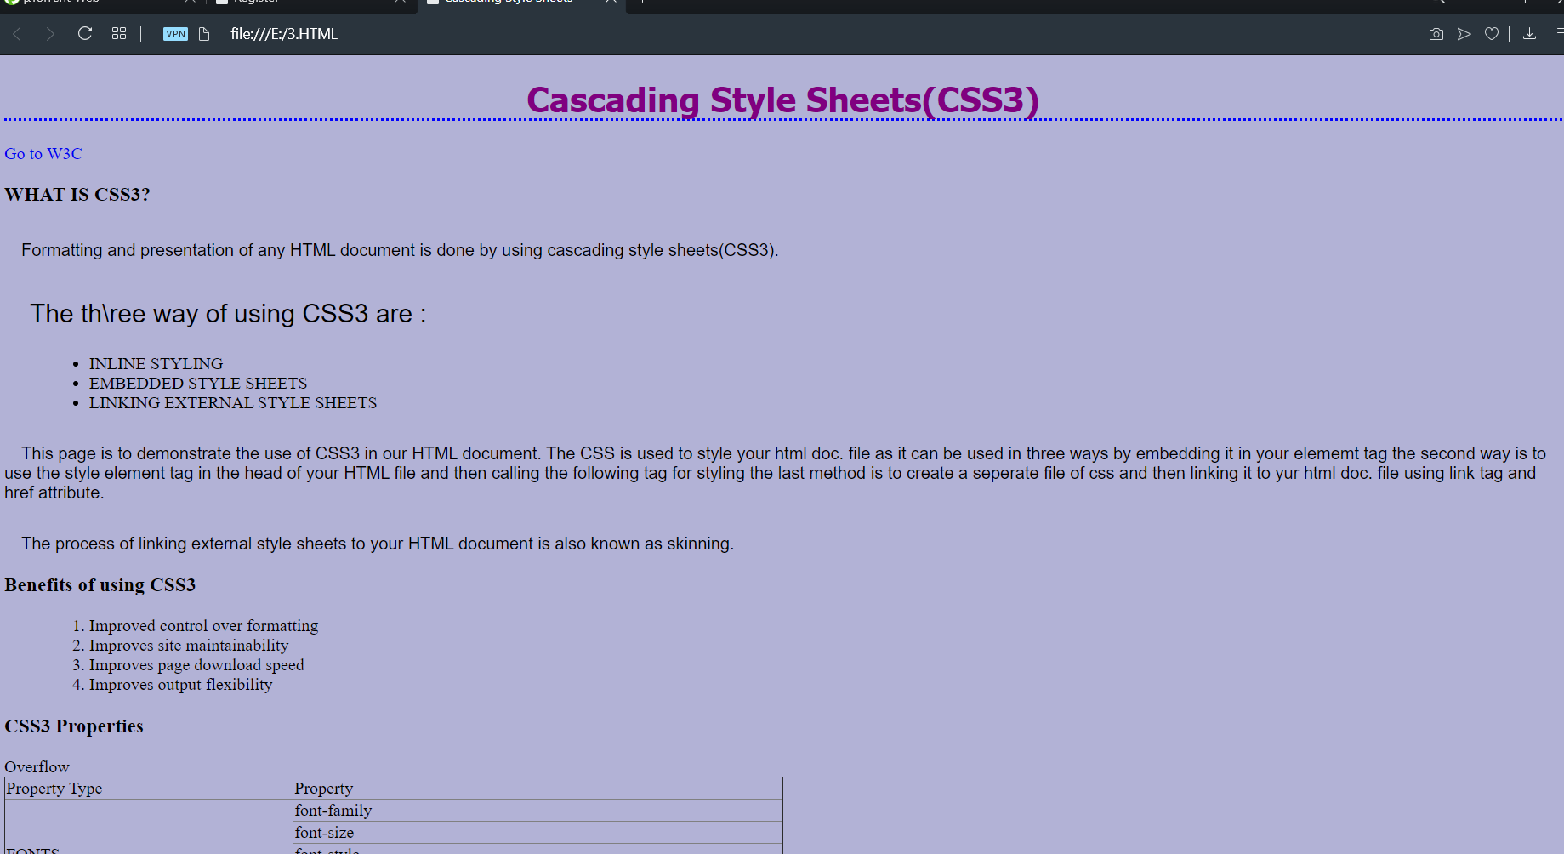

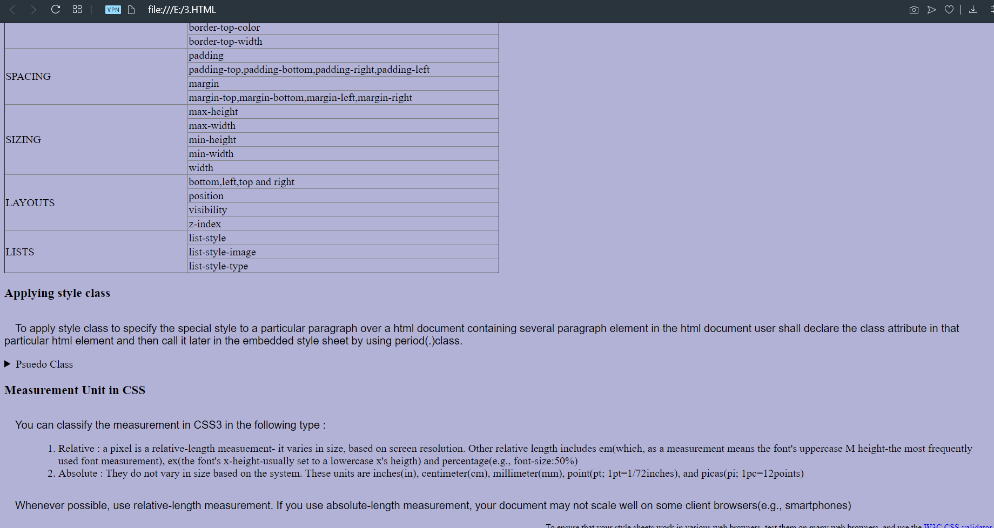

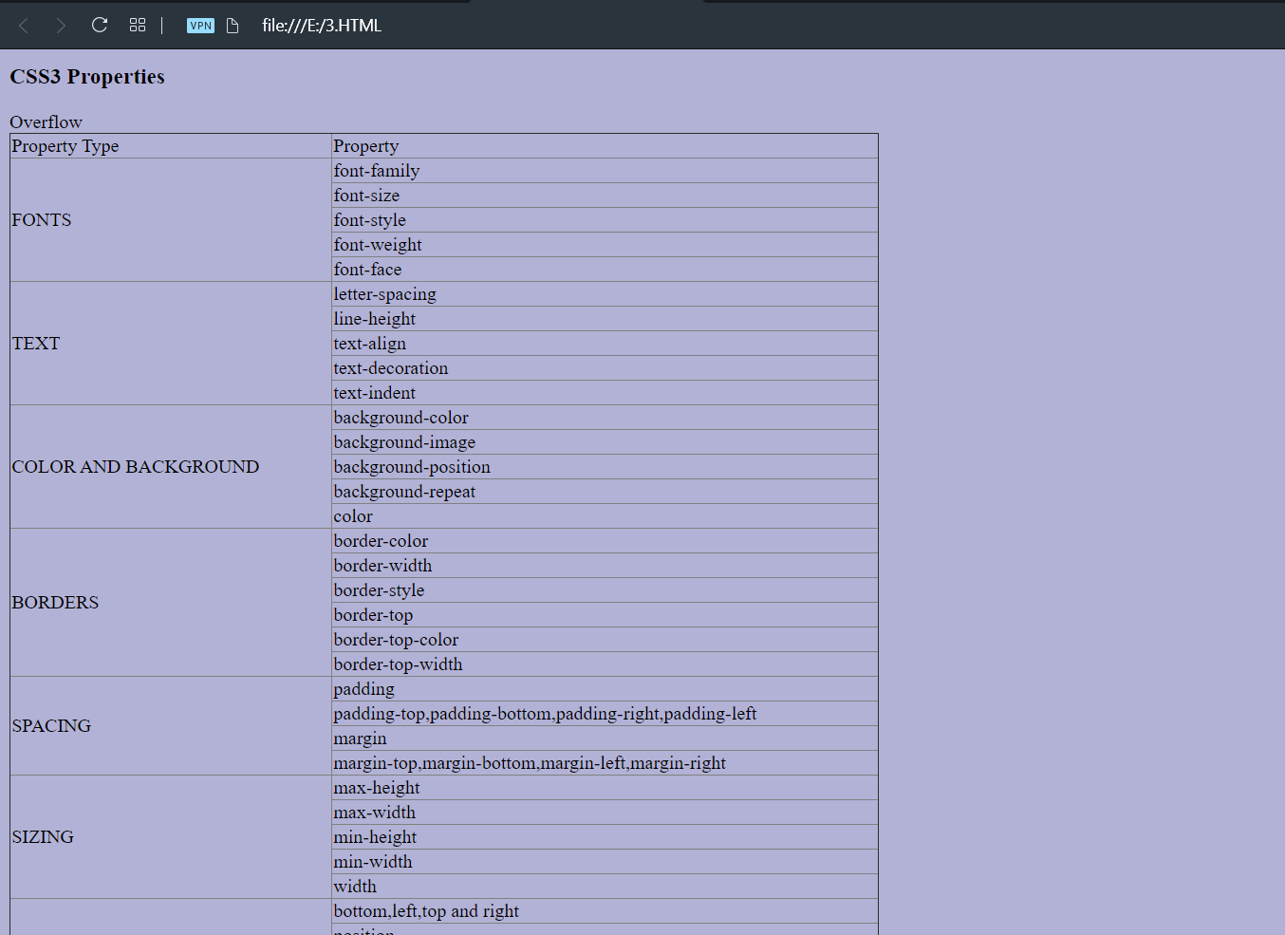

**PROGRAM-4**

**Procedure:-**

**Step** 1

**Download and Install Tomcat**

1. Go to http://tomcat.apache.org/download-70.cgi then go to the Binary Distribution/Core/

and download the "zip" package (for example "apache-tomcat-7.0.40.zip")

2. Now **unzip** the downloaded file into a directory of our choice.

**Step** 2

Check the installed directory to ensure it contains the following sub-directories:

a.bin folder

b. logs folder

c. webapps folder

d. work folder

e. temp folder

f. conf folder

g. lib folder

Step 3

Create Environment variable JAVA_HOME.

Configure Tomcat Server

The configuration files of the Apache Tomcat Server are located in the "conf" sub-directory of our

Tomcat installed directory, for example "E:\myserver\tomcat7.0.40\conf". There are 4 configuration

XML files:

1. context.xml file

2. tomcat-users.xml file

3. server.xml file

4. web.xml file

Before proceeding, make a BACKUP of the configuration files.

**Step** 4(**a**) "**conf**\**web**.**xml**"; **Enabling a Directory Listing**

Open the configuration file "web.xml". We shall enable the directory listing by changing "listings" from

"false" to "true" for the "default" servlet.

<param-value>**true**</param-value> like:

**Step** 4(**b**) "**conf**\**server**.**xml file**"; **set the TCP Port Number**

Open the file "server.xml" in a text editor.

The default port number of Tomcat is 8080. We can change it according to our need.

**Step** 4(**c**) "**conf**\**context**.**xml**"; **Enabling Automatic Reload**

In that we set reloadable="true" to the <Context> element to enable automatic reload after code

**Step** 4(**d**) (**Optional**) "**conf**\**tomcat**-**users**.**xml**"

It is used to manage Tomcat by adding the highlighted lines, inside the <tomcat-users> elements.

In that we can add a password and username as an optional step.

**Step** 5

Now, start the tomcat server

Executable programs and scripts are kept in the "bin" sub-directory of the Tomcat installed directory

**Step** 5(**a**) **Start Server**

**Step** 5(**b**) **Access the Server**

Open a browser then enter the URL "http://localhost:8080" to access the Tomcat server's welcome

page.

Output-

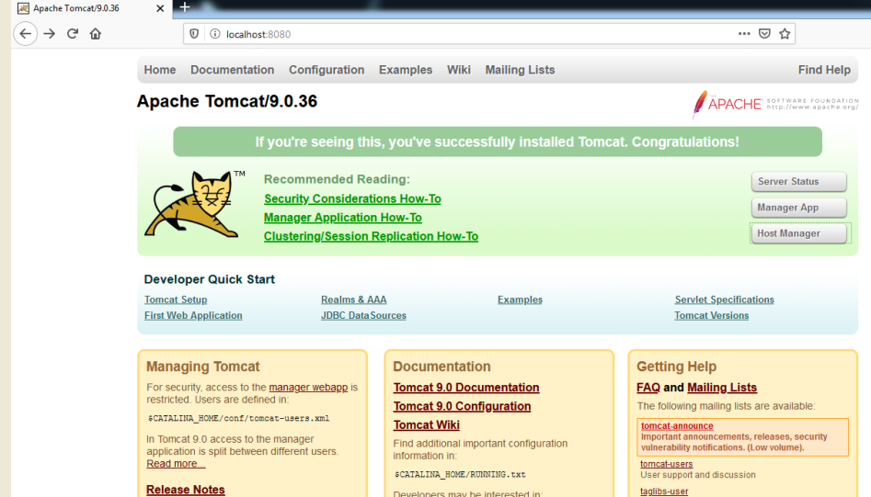

**PROGRAM-5**

<?xml version="1.0" encoding="UTF-8"?>

<Remainder>

<Birthday>

<Date>6 MAY</Date></br>

<name>RACHIT</name></br>

<Venue>IIIT SONEPAT Haryana</Venue></br>

</Birthday>

<Meeting>

<Date>10 July, 2020</Date></br>

<Venue>AUDITORIUM HALL-A IIIT SONEPAT</Venue></br>

<Topic>INTRODUCTION TO WEB DEVLOPMENT</Topic></br>

</Meeting>

</Remainder>

**Advantages of web.xml files**

* The first benefit of the xml is we can write it in our won markup language. There is a no restricted to limited sets of tags. By defining our own tag we can create a markup language in terms of specific problem.
* Searching the data is easy and efficient.

OUTPUT:

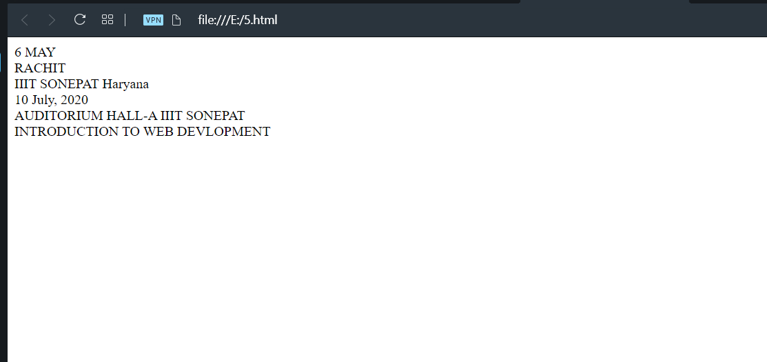

**PROGRAM-6**

|  |
| --- |
| <html> |
|  | <head> |
|  | <meta charset="UTF-8"> |
|  | <meta name="viewport" content="width=device-width, initial-scale=1.0"> |
|  | <title>Website</title> |
|  | </head> |
|  | <body> |
|  | <?php |
|  |  |
|  | $name = $email = $gender = $comment = $website = ""; |
|  |  |
|  | if ($_SERVER["REQUEST_METHOD"] == "POST") { |
|  | $name = test_input($_POST["name"]); |
|  | $email = test_input($_POST["email"]); |
|  | $website = test_input($_POST["website"]); |
|  | $comment = test_input($_POST["comment"]); |
|  | $gender = test_input($_POST["gender"]); |
|  | } |
|  |  |
|  | function test_input($data) { |
|  | $data = trim($data); |
|  | $data = stripslashes($data); |
|  | $data = htmlspecialchars($data); |
|  | return $data; |
|  | } |
|  | ?> |
|  |  |
|  | <h2>PHP Form Validation Example</h2> |
|  | <form method="post" action="<?php echo htmlspecialchars($_SERVER["PHP_SELF"]);?>"> |
|  | Name: <input type="text" name="name"> |
|  | <br><br> |
|  | E-mail: <input type="text" name="email"> |
|  | <br><br> |
|  | Website: <input type="text" name="website"> |
|  | <br><br> |
|  | Comment: <textarea name="comment" rows="5" cols="40"></textarea> |
|  | <br><br> |
|  | Gender: |
|  | <input type="radio" name="gender" value="female">Female |
|  | <input type="radio" name="gender" value="male">Male |
|  | <input type="radio" name="gender" value="other">Other |
|  | <br><br> |
|  | <input type="submit" name="submit" value="Submit"> |
|  | </form> |
|  |  |
|  | <?php |
|  | echo "<h2>Check Your Entry:</h2>"; |
|  | echo $name; |
|  | echo "<br>"; |
|  | echo $email; |
|  | echo "<br>"; |
|  | echo $website; |
|  | echo "<br>"; |
|  | echo $comment; |
|  | echo "<br>"; |
|  | echo $gender; |
|  | ?>   |  |  | | --- | --- | |  | </body> | |  | </html> |   **OUTPUT:** |

**PROGRAM-7**

<html>

<head>

<title>Reaction Timer</title>

<style type="text/css">

body {

font-family: sans-serif;

}

#shape {

width: 200px;

height: 200px;

background-color: red;

display: none;

position: relative;

}

.bold {

font-weight: bold;

}

</style>

</head>

<body>

<h1>Test Your Reactions!</h1>

<p>Click on the boxes and circles as quickly as you can!</p>

<p class="bold">Your time: <span

id="timeTaken"></span></p>

<div id="shape"></div>

<script type="text/javascript">

var start = new Date().getTime();

function getRandomColor() {

var letters = '0123456789ABCDEF'.split('');

var color = '#';

for (var i = 0; i < 6; i++ ) {

color += letters[Math.floor(Math.random() * 16)];

}

return color;

}

function makeShapeAppear() {

var top = Math.random() * 400;

var left = Math.random() * 400;

var width = (Math.random() * 200) + 100;

if (Math.random() > 0.5) {

document.getElementById("shape").style.borderRadius = "50%";

} else {

document.getElementById("shape").style.borderRadius = "0";

}

document.getElementById("shape").style.backgroundColor = getRandomColor();

document.getElementById("shape").style.width = width + "px";

document.getElementById("shape").style.height = width + "px";

document.getElementById("shape").style.top = top + "px";

document.getElementById("shape").style.left = left + "px";

document.getElementById("shape").style.display = "block";

start = new Date().getTime();

}

function appearAfterDelay() {

setTimeout(makeShapeAppear, Math.random() * 2000);

}

appearAfterDelay();

document.getElementById("shape").onclick = function() {

document.getElementById("shape").style.display = "none";

var end = new Date().getTime();

var timeTaken = (end - start) / 1000;

document.getElementById("timeTaken").innerHTML = timeTaken + "s";

appearAfterDelay();

}

</script>

</body>

</html>

OUTPUT:

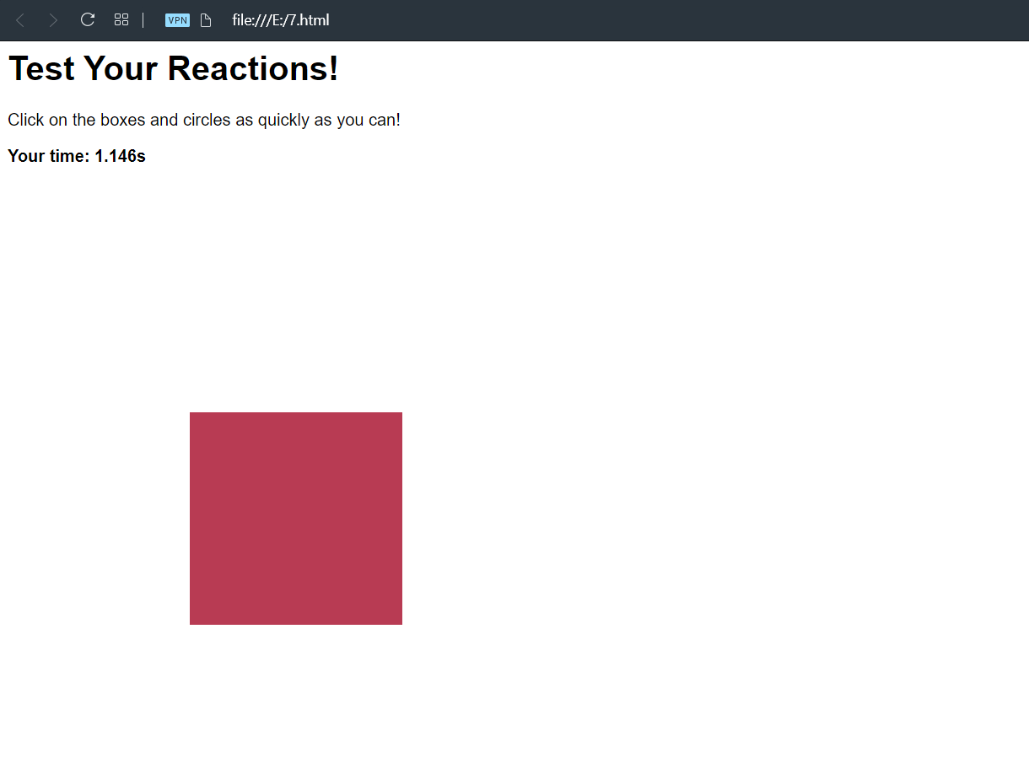

**PROGRAM-8**

1. PYTHON PROGRAM TO ADD TO NUMBERS

Num1= 1.5

Num2= 6.3

Sum= num1 +num2

Print(‘ sum of {0} and {1} is {2}’.format(num1,num2,sum))

OUTPUT:

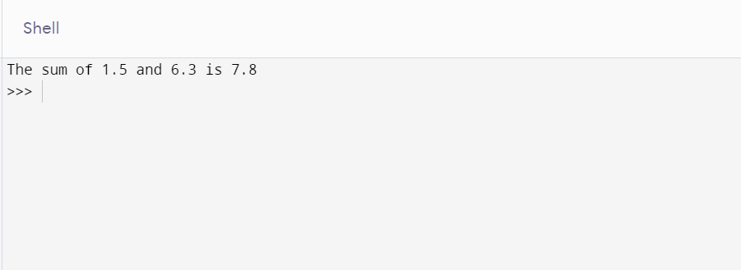

1. PYTHON PROGRAM TO CHECK NUMBER IS ODD OR EVEN

Num = int(input(“enter a number:”))

If( num%2==0:

Print (“{0} is even”.format(num))

Else:

Print(“{0} is odd”.format(num))

OUTPUT:

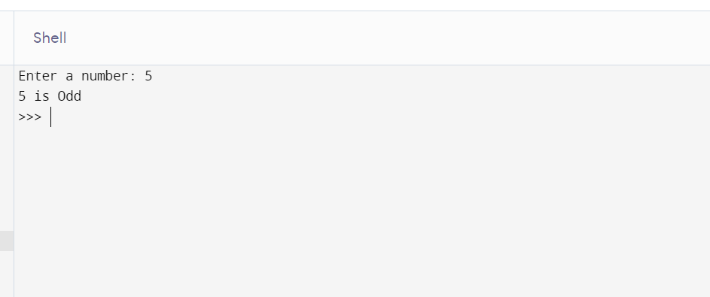

1. PYTHON PROGRAM TO CHECK WHETHER A STRING IS PALINDROME OR NOT

My_str = ‘mom’

My_str = my_str.casefold()

Rev_str = reversed(my_str)

If list (my_str) == list(rev_str):

Print(“the string is palindrome”

Else:

Print (“the string is not a palindrome”)

OUTPUT:

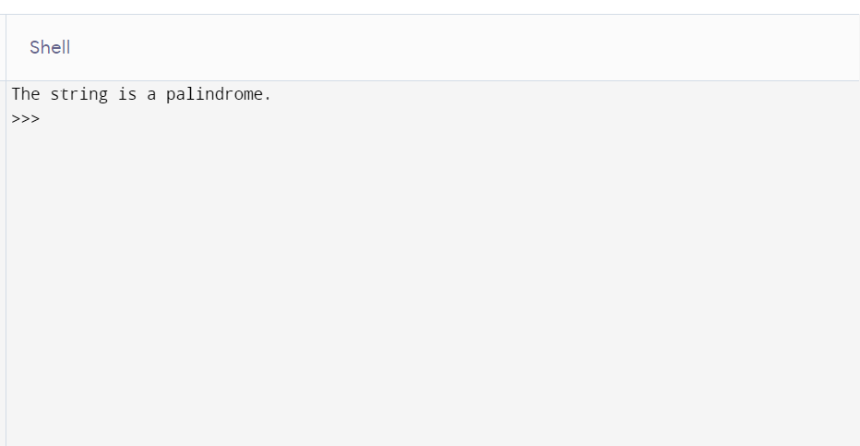

**PROGRAM -9**

1. USE PYTHON TO CREATE PROGRAMS FOR SCIENTIFIC COMPUTATIONS:

import math

print ("Log value for base 2: ")

print (math.log2(20))

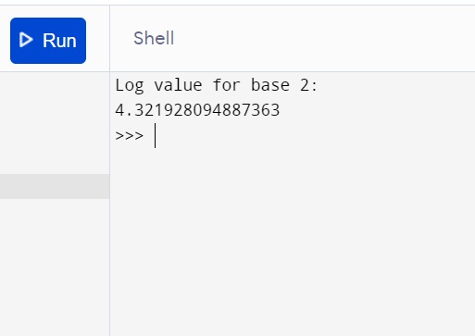

(ii)USING PYTHON TO CALCULATE SCIENTIFIC COMPUTATIONS:

import math

print("What Do You Want To Calculate?")

print("A - Sine")

print("B - Cosine")

print("C - Tangent")

t = input()

print("Enter Angle In Degrees: ")

ang = float(input())

pi = math.acos(-1)

if t == "A" or t == "a":

print("sin(" + str(ang) + ") = " + str(math.sin(ang*pi/180)))

elif t == "B" or t == "b":

print("cos(" + str(ang) + ") = " + str(math.cos(ang*pi/180)))

elif t == "C" or t == "c":

print("tan(" + str(ang) + ") = " + str(math.tan(ang*pi/180)))

OUTPUT: 